**Technical Product Specifications**

**Team:** We can do it

**Class:** EE 585

**Team Members:**

Abdulrahman Alharbi

Dhari Alenezi

Andrew Nguyen

Elina Do



**Date:** 4/11/2021

**A product definition statement:**

The Wichita Police department was having a problem with organizing and keeping track of their paper work with citizens. When they give papers that have crucial information for citizens like accident reports, tickets etc. There is a high chance that paper gets lost from the policeman or the citizens. Which leads to more lost time between the citizens and the police department to figure out the right papers needed for each citizen from the huge numbers of paperwork. We want to make the process between Policemen and citizens in a way that can be done through their phones. So, we want to build an application that allows the Wichita Police department to have the information they need on their phones. Furthermore, the application will allow a faster and easier way of sending the information to the victims phones. The application will share the websites pages where the information is into a QR code. That the victims can scan the QR code and get right to the webpage that they need. Also, we will make the application compatible with IOS and Android devices by the use of Flutter SDK.

**Realistic product constraints:**

Some realistic product constraints that we have would be the safety. Because the Wichita Police Department has some information that they want to be protected, we will have to find servers and such that can guarantee that the information will be kept secure. We also need to make sure it is a private app and that others will not be able to access it. Another constraint is the economic constraints, obviously we have a budget and we must work to make our product as cost efficient as possible while maintaining all of the requirements and not decreasing the value of our work. A requirement that the WPD gave us that is a bit of a constraint is that the app must also be functional offline. This would mean that we have to keep all of the information local which could take up a lot of storage on the phones.

Regulatory Constraints

* The mobile application and web-based application will be synced so that the officer’s can use their phones to access the documents and pdfs
* Protected information: Criminal History Record Information, information that the public cannot access
* Database security - data is secure from other risks such as NoSQL Injections

Operational Constraints

* Private application will only be available to the police
* Compatible with IOS 14.4 - iPhone SE 2nd Generation
* Low maintenance - the WPD will need to be able to maintain and update it when needed

Interface Constraints

* The use will need to sign in the to the application with their badge number
* Must be user friendly/easy to use

**Appropriate engineering standards that must be considered for the product or project design.**

* Clearly identifies, by citation or reference, specific industry and regulatory requirements that mandate that software be designed to perform in a certain manner.
* Clearly explains the overall software design including data integration, data protection, and data integrity. Clearly defined function used to meet operational requirements.
* Limitations and constraints such as economic, ethical, health, and safety are considered and details are provided indicating the understanding of constraints and limitations of design.
* Completed, well organized, clear purpose, and available for reference during requirements review.
* Alternative designs are considered and evaluated appropriately; the method of analysis is clear.

**UX/UI Design:**

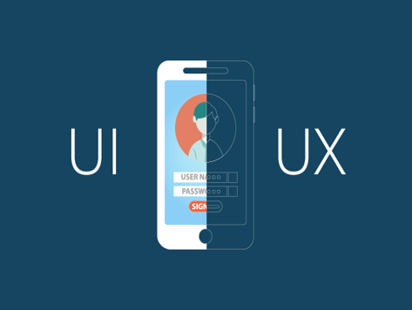[11]

For the Designing of application we need to focus on the User interface and User Experience and we have to test each one of them. Before we go to the development and writing the code of the application. We have to grasp a good knowledge of the features that the Wichita Police Department needs for the application. And to make sure that the application is an easy and seamless application for the Wichita Police department. We will be designing the application with its icons and layouts as an initial sample by using the UI/UX concepts. And will provide to WPD so they can test the application and provide us with feedback to better the design of the application.

**UI Design Wireframe:**

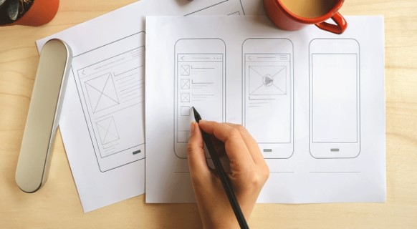[10]

We will start the designing process for the application by making the wireframe design for the application. The wireframe is a low fidelity design for the application is an initial design for the application in an easy and fast way of designing. It's a drawing for the application layouts ,icons and page views for the application on papers and it is a black and white design for the application. Wireframe is a fast way of designing the application and changing the design as we go in the design process. It's better than writing codes and trying to recode the new design again and again which takes a lot of time and effort. With a wireframe design you can just change your drawing and go to the new design. That is the reason why we will start with the wireframe design first when we finish the wireframe design and we are confident about the design. We will check with the WPD if they like the design with the wireframe and decide to modify the design or go to the next stage. That will depend on the opinion of WPD of the WireFrame.

**UX Design**

At this point we will have finished the User interface of the application and we will go to the next stage which is the User experience design for the application. Here we will take our final wireframe that has been checked and agreed on by the WPD. And make an interactive prototype for the application using Adobe XD. Adobe XD is a software that allows us to make an interactive prototype for the application that can be used and tested to make sure about the User experience for the application. And this interactive prototype can be used from the WPD to check if they like the application. And to give us feedback whether the application is easy to use or not. And they can tell us specifically what is making the application not good to use and what needs to be changed for the application. Using the interactive prototype is an important method to check your design for the application with the users and developer before writing the codes for the application. Which saves a lot of time in the designing and development stages of the creation of the application.

**Software Details**

**Product Specifications**:

The product that we will build will depend entirely on the software, and we will be using the hardware of the smartphone such as the camera, and the internet. In our project, we will need four basic things. They are a mobile application, server, database, and web page. We will talk in detail about all of them, then we will talk about the mechanism of linking them, and how they will work.

**1- Mobile Application (Flutter)**

**Description:**

The main thing in our project is the mobile application. Users, including the police, will need the app to solve the problem they face, which we mentioned this problem in a product definition statement section. During the generation of the QR Code, the application will be able to attach the application's user information such as police information and other things that will make the process easier between citizens and the Police Department.

**Requirements:**

* Phone (iOS or Android)
* Internet Access

**Software Development Kit (SDK)**

In order to develop an app we need a software development kit which is a collection of software tools that helps us to develop an app. So, we did research, and we found there are many SDK that will help us to develop the app. Some of them are specialized only for one specific platform such as iOS or Android, and some of them export slow applications.

Comparison between SDKs

|  | **Native** | **React Native** | **Flutter** |
| --- | --- | --- | --- |
| Advantages | - High performance which means fast app.[1] | - Single code base, which means that one code will work for both platforms. iOS/Android [1] | - High performance.[3]  - Expressive and Flexible UI  - Single code base, which means that one code will work for both platforms. iOS/Android. [1] |
| Disadvantages | - Time consuming, as you know that in our project we will not just need an application that works on the phone. Also, we need an application that works on the computer.The problem here is if we want to develop one application on a computer, and one application on phone, We will need to write the code twice in two different programming languages. Also, we will take more time in the development process. [1] | - Slow app compared to Native app.[1] | - Does not support 3D, and in our project we do not need 3D components. |

So, after we did our research and the comparison. We found the Flutter SDK , and Flutter is an open source UI software development kit that was created by Google. The best thing about Flutter SDK is that it is used to develop an application for Android, iOS, windows, and other platforms with just one single codebase. Also, the application that this SDK exports. gonna be a Native performance which means really fast.

**2- Server (Node.js)**

**Description:**

We will need the server in order to keep the authentication feature activated within the app such as Sign In inside the app. Also, we will need the server in order to keep the mobile application communicating with the server to update the data to the latest version.

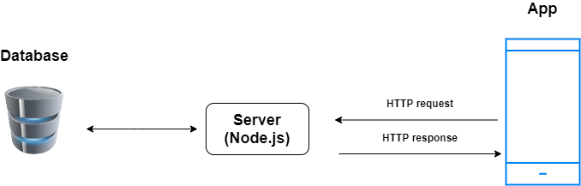

We will use HTTP requests in Flutter SDK that will help us to connect the app with the backend server. We will use a package called Dio Flutter. This package will enable the application to communicate with the server.

Link of package: <https://pub.dev/packages/dio>

**Communication Method:**

First, when the user opens the mobile application. The APP will send HTTP requests to the server to get the last updated data, then the server will receive the request from the mobile app, then the server will communicate with the database to get the last updated data. After that, the server will send an HTTP response to the mobile app, then the mobile app will receive these data, and the mobile app will save it locally.

**Node.js:**

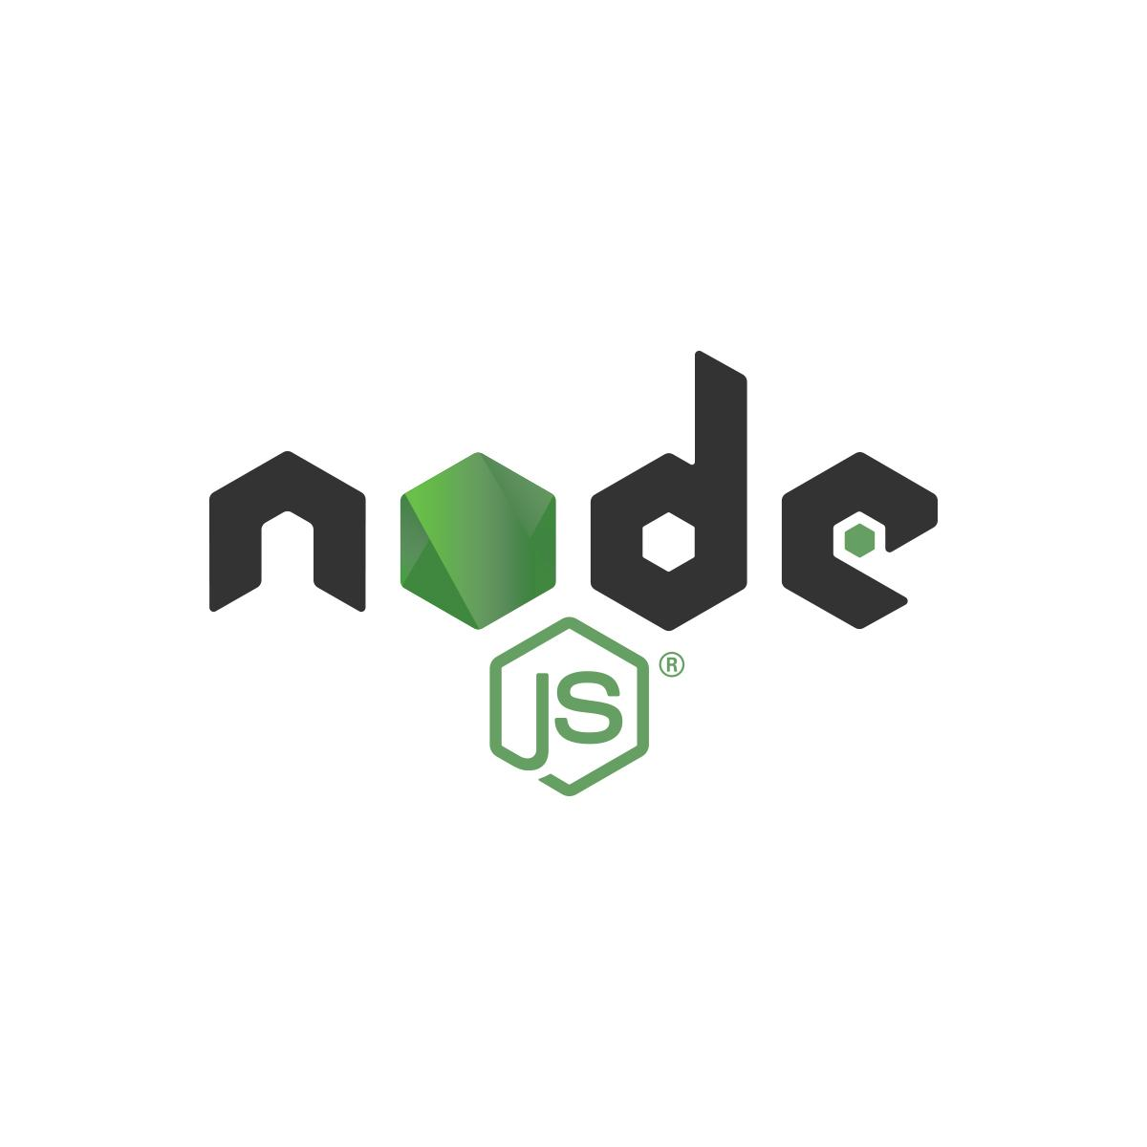[4]

Nodejs will let us write codes for the server-side which is called the Backend side. The codes that we will write on the backend will be written in Javascript programming language.

The advantages and Disadvantages of Node.js:

| **Advantages** | **Disadvantages** |
| --- | --- |
| * Fast-processing, Node.js is fast, so when the app sends HTTP to the server the server will respond to this request very fast. [5] * Open source, which means tools that are free-to-use, and the community behind it. [4] * Strong corporate support. Many companies such as IBM, Microsoft and PayPal use Node.js, so there is a lot of support from these companies for Node.js. [5] | * The relational databases are a pain if inside Node.js. [2] * Node.js is not suited for CPU-intensive tasks. [2] |

So, we found that Node.js is compatible with our project, so we will use the node on the server-side.

**3- Database (MongoDB)**

[6]

In our project we will need a database in order to store the latest data update.Also, the database will help us to keep the data in the application mobile synchronized with the last update. The mobile application will communicate with the data through the server that was developed by the node. For this, we need a database that is very fast. Aslo, we need a database that has easy scalability. So, because of these reasons we did research about the best database for our project.

|  | **MySQL** | **MongoDB** |
| --- | --- | --- |
| **Advantages** | - MySQL is faster at selecting a large number of records. [7] | - MongoDB is very flexible. [8]  - The Scalability inside the MongoDB is more easy than MySQL. [7]  - MongoDB is significantly faster at inserting or updating a large number of records.[7] |
| **Disadvantages** | - Time consuming, developing inside MySQL will take more time than MongoDB. [9] | - Transactions using MongoDB are complex.[8] |

So, after we did our research and the comparison. We found MongoDB is suitable for our project because we will need an easy Scalability database. Also, the mobile app will update the data continuously for that MongoDB is significantly faster at inserting or updating a large number of records.

**4- Web Page**

**Description:**

After the mobile application generates a QR code the victim(s) will then scan the code with their mobile device. Once the QR code is scanned, the victim(s) mobile device will then open up the browser to the link to provide important information about the crime. In order to communicate with the back-end server, we will be using React.js framework.

**Requirements:**

* Phone (iOS or Android)
* Internet Access

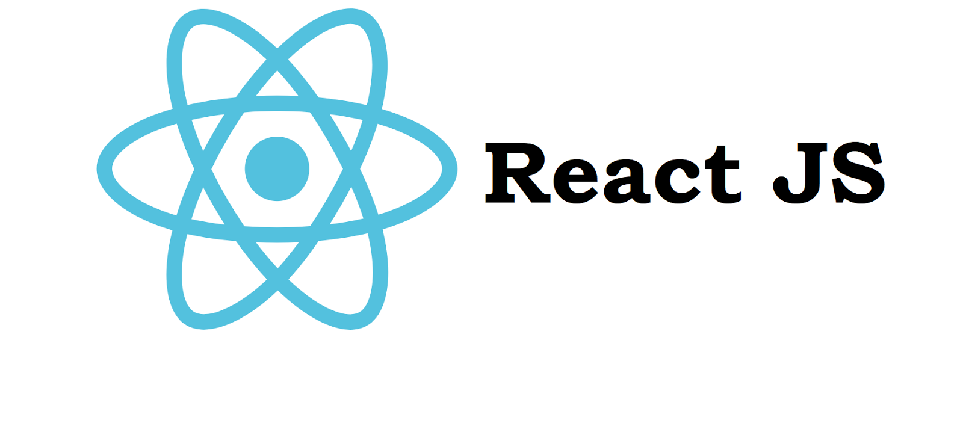[12]

Apart from using HTML, CSS, and Javascript for the web app part of the project, we chose to use the React framework to run the web app. We chose React over all the other frameworks because it is the most supported framework out there at this time. There are many libraries that support this framework so that we can utilize it within this project for the Police Department. It also has great performance compared to other frameworks since it uses something called virtual DOM. They’re lightweight and built on a server which helps with the load on the browser by reducing it. A big part of using this framework is that the data-binding process is unidirectional and no additional workload is created when done so. A plus is that it is also mobile friendly with a simple library called React Native.

**Communication Method:**

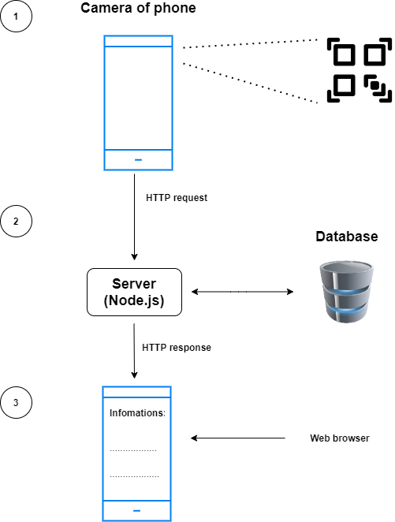

1- First, the phone will scan the QR code, and it will open a URL link by using the browser.

2- Second, the browser will send HTTP requests to the server that we built, and the server will communicate with the database that was built by MongoDB, and it will fetch the data that related to the QR code information.

3- Then the server will send an HTTP response to the mobile browser, and it will open a webpage which has important information for victims.

---------------------------------------------------------

**Each member of the team will sign the report after the statement “I have read the entire report and it meets my personal quality standards”.**

**I have read the entire report and it meets my personal quality standards. -Abdulrahman Alharbi**

**I have read the entire report and it meets my personal quality standards. - Dhari Alenezi**

**I have read the entire report and it meets my personal quality standards. - Elina Do**

**I have read the entire report and it meets my personal quality standards - Andrew Nguyen**

**Work Cited**

[1] Native Vs Cross-Platform Development: Pros & Cons Revealed:

<https://uptech.team/blog/native-vs-cross-platform-app-development#:~:text=Native%20development%20produces%20apps%20with,on%20both%20Android%20and%20iOS.>

[2] Node.js - reasons to use, pros and cons, best practices!:

<https://www.voidcanvas.com/describing-node-js/>

[3] Flutter website: <https://flutter.dev/>

[4] Node.js website:<https://nodejs.org/>

[5] The Good and the Bad of Node.js Web App Development: <https://www.altexsoft.com/blog/engineering/the-good-and-the-bad-of-node-js-web-app-development/>

[6] How to get started with MongoDB in 10 minutes: <https://medium.com/free-code-camp/learn-mongodb-a4ce205e7739>

[7] MongoDB vs MySQL Differences: <https://www.mongodb.com/compare/mongodb-mysql>

[8] MongoDB vs. MySQL: What's the difference: <https://www.guru99.com/mongodb-vs-mysql.html>

[9] The Pros and Cons of 8 Popular Databases: <https://www.keycdn.com/blog/popular-databases>

[10] CareerFoundry

<https://careerfoundry.com/en/blog/ux-design/the-difference-between-ux-and-ui-design-a-laymans-guide/>

[11] Common Misconceptions About UX/UI Designers: <https://analyticsindiamag.com/common-misconceptions-about-ux-ui-designers/>

[12] Simple timer in React: <https://medium.com/@650egor/react-30-day-challenge-day-1-simple-timer-df85d0867553>